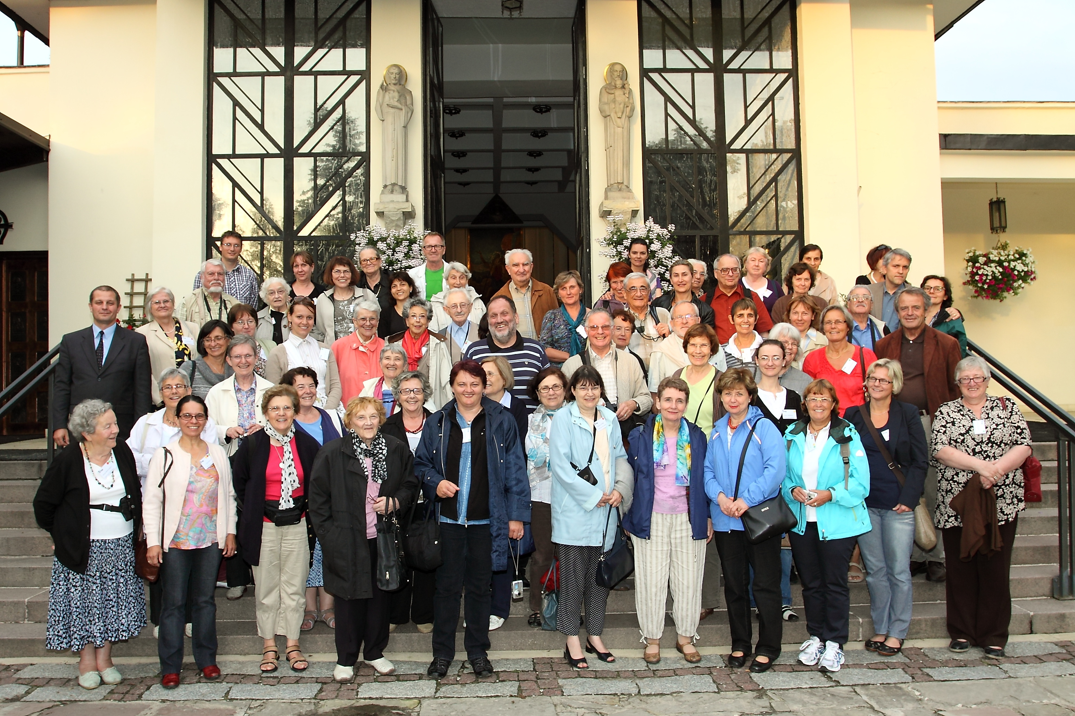

In front of the church of Podkowa Leśna Foto: Grzegorsz Dąbrowski

56th International Meeting from July 23rd to 28th/29th, 2011

Full of joy after two years, 64 colleagues from 14 European countries have participated in this meeting of SIESC at Warsaw. To the topic “Spirit of community versus spectres of the past – the role of teachers, especially Christian teachers, in the purification of recent memory” three speakers presented a lot of ideas and personal experiences. Katarina KRUHONJA, of the Centre for Peace, Non-violence and Human Rights at Osijek in Croatia, gave a survey on the post-war situation in her native country and the efforts of transitional and restorative justice, on methods of dealing with the past and working for sustainable peace. Marcin KULA, professor of recent history at Warsaw University and Léon Kozminski Academy, proposed as the objective of teaching history providing students with a knowledge of the multiple facets of the human condition in order to enable them to gain a greater understanding of other people as simply people. And Krzysztof CZYŻEWSKI, director of the Centre “at the border – arts, cultures, nations” at Sejny at the Polish-Lithuanian border, talked about the culture of long-term coexistence and the practice of the ethos of the borderland, and showed how good memories and neimars, constructors and guardians of bridges, can facilitate the coexistence of people of different cultures.
In international language groups the participants expressed their personal experiences and gained advantage of the open and committed contributions of the others. Moreover, the conversations at the table and in the corridors created familiarity and friendships across the borders.
Our friends of KIK have also prepared an insight into culture and history of Poland: the Old Town of Warsaw, rebuilt after World War II, the impressive University Library, the Palace of Culture (Stalin’s “present” for Warsaw), places connected to Frédéric Chopin (Żelazowa Wola with a very modern and hospitable school and a concert at Brochów), Kazimierz Dolny (a beautiful town on the banks of the Vistula), and Lublin with its important and tragic history.
We also prayed together in many languages and celebrated a solemn mass together with Bishop Tadeusz Pikus, and we met responsible persons of KIK. It’s to our colleagues of the teachers’ section of KIK, a member of SIESC, that we ought to give thanks from all our heart for the concept, the preparation and the organisation of this fruitful meeting in a Formation Centre in the midst of a little wood. We will not forget the friendliness and the constant work of Małgorzata Wojciechowska, Elżbieta Jaworska and Grzegorz Dąbrowski.

